Anomaly Detection Research

Tasks Completed up to now:
- AMPDs Dataset – main dataset for the project.
- Adding artificial anomaly data ~800+ anomalies (~14%) across 14 distinct types — contextual (unusual hours, weekend/weekday swaps, low-occupancy usage), sequential (stuck on/off, gradual drift, sustained overload), collective (multiple appliances together, impossible combos), and point (power spikes, sensor glitches).
- Kept Dataset range for training and testing to 2 months.
- tsfresh & FRESH-pruning of the raw dataset to make a new dataset. Added weather data as well.
- 15 min window for tsfresh extraction pruning.
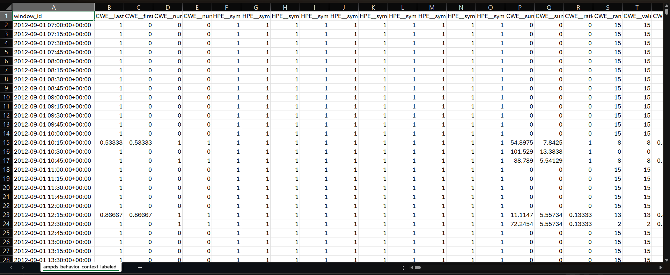

- Trained NMF on normal-only data (novelty detection framing), scored anomalies via reconstruction error. Fixed convergence issues (loosened tol to 1e-3, tuned max_iter) — cut runtime dramatically (e.g. ~720s → ~65s at comparable K) with no real accuracy cost.
- Went through 4 different reconstruction error (inspired from the research papers)
- Basic Default Recon Error
np.linalg.norm(X_ori - X_recon, axis=1)
- Ae-sad (this didn’t work out, the implementation was a bit complex and required making a NMF from scratch – the sklearn NMF wouldn’t work)
error = np.sum((X_ori - X_recon)**2, axis=1)
- LFR
Investigating recon gap in latent space instead of input space
latent_error = np.linalg.norm(W - W_reconstructed, axis=1)
(not exactly LFR).

- RGAnomaly
Multiple recon signals combined
error = alpha * input_error + (1 - alpha) * latent_error

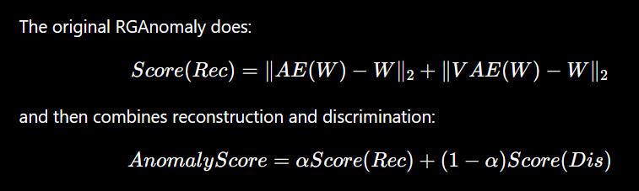

Our formula -
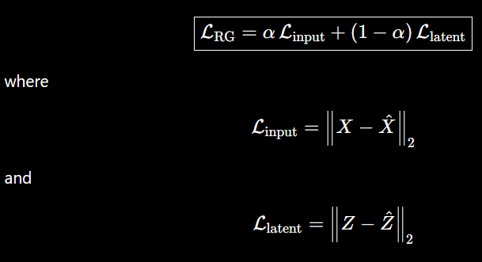
Can also be turned into a anomaly score…

Observations
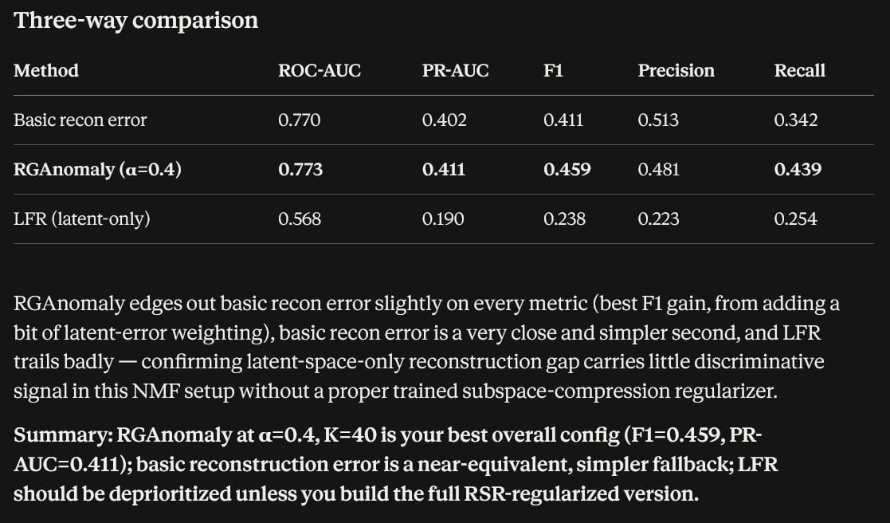
Max_iter = 1500 in these cases.

PYOD models on the same dataset (not stratified)
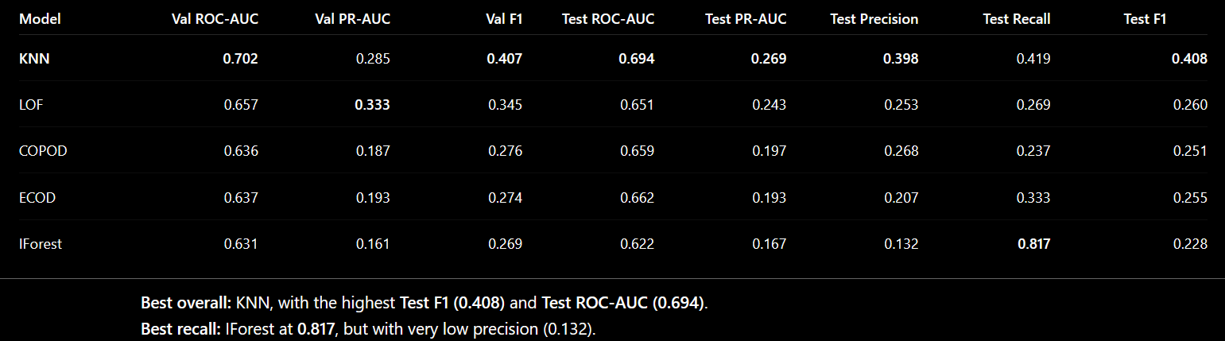
Stratified
